# Car navmesh

To let cars drive autonomously through the city, a navmesh was created by Jesper. The most challenging part was to let cars keep driving on the right side of the road. In order to achieve this, the road was split up in parts: crossroads, lanes, line sections and dead ends. The dead ends were left out of the navmesh to avoid cars getting stuck at the end. A view of the navmesh can be seen in the figure below.

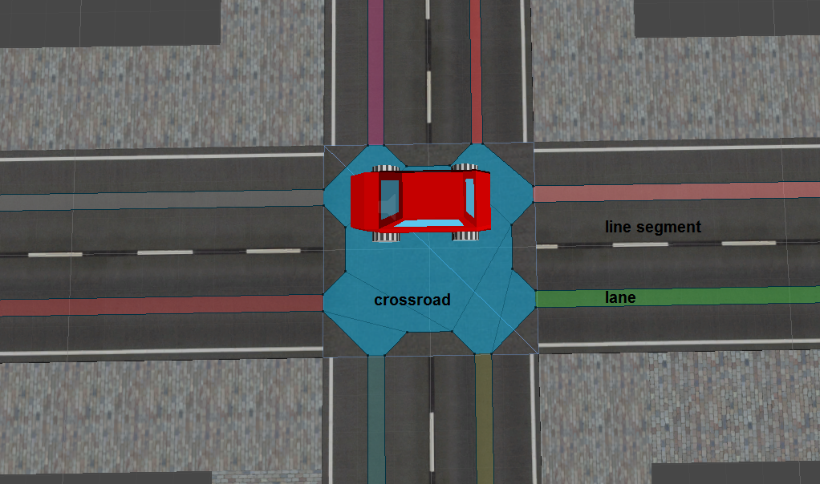Because the path is calculated for the centre of the car and only the centre of the car stays on the navmesh, the lanes are narrow to avoid cars driving over the curb or the left lane. Every crossroad has its own index. All lanes to the left and below a certain crossroad have a lower index or the same and the lanes above and to the right have a higher index. When a car hits a crossroad, the costs for all lanes are again set to give all right sided lanes from that crossroad a low cost and all left sided roads a high cost. When a car gets within two units from its destination, a new destination is set and so the cars will keep driving around.

# Code quality

Because multiple group members worked on the same scripts at different times, it was important to keep code clean organized and readable. This was done by separating code in functions as much as possible and leaving short comments as to what these functions were for. This made it possible for us to add to and change each other’s code. However, it did result in some problems. Sometimes code was dependent on other code, certain tags or other elements, which every now and then led into braking someone’s code by changing or adding something yourself. Luckily these errors were always easily fixed by looking over the code in question together.

# Process and teamwork

At the start of the process SCRUM was used extensively. Creating issues, assigning team members and setting a deadline cost a lot of time and therefor it was used less near the end of the process. It was also hard to decide when a component was finished. Most components were adapted many times up until the very end. As an addition to SCRUM we did always go over the issues that needed to be done at the beginning of every group session in a small discussion so everyone knew what to do that day. This also gave us a very regular update on how far we were in the process and if certain issues were harder than expected.

Working together as a team went great. We tried to always get together at the project sessions which helped a lot. Boyd and Rense as lead programmer and world builder respectively kept to their roles very well. The rest of the roles were not as clearly assigned to one person. Thomas, Luuk and Jesper all worked a lot in blender doing artistic things as well tackling more programming based issues as AI and web & database components or creating parts of the world like the indoor scenes and the road system. Thomas also did most of his work as a game designer, including writing the game design document.

All in all the most important thing is that we did not have any issues working together. Everyone worked to his full potential and there was no weak link. This created a relaxed but driven atmosphere in the group.

# Conclusion

At the start we had many ideas to make this a great game. Looking back on it, we were a little bit too ambitious which means the result is not exactly as we had in mind. Because it was important to create challenging components in the game, we had to cut down on some of the gameplay aspects. This means that it is not as an exciting game as we were going for. In retrospect we should have probably chosen a game with an easier game design, giving us more time to focus on the gameplay and the juiciness. We were very happy with the teamwork. The one thing that we would improve for a next game is improving our knowledge of all the programs before starting to build the game. This would save us from redoing the same thing over and over again. (But I guess that is part of the job)

In conclusion we are very happy with the end result. All the components are there. We just needed a little more time to make it into a juicy exciting game.